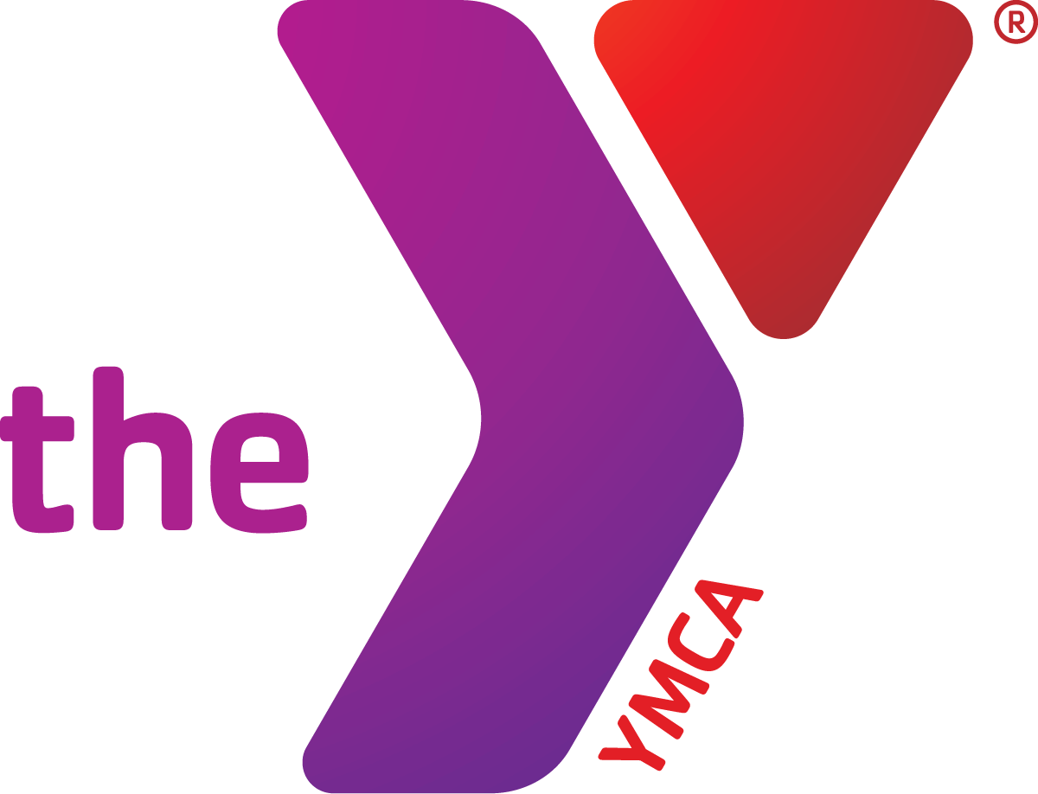**TRI-TOWN PROGRAM REGISTRATION FORM**

**Directions:** Please legibly print and complete all components of the registration and return with full payment to:

***ATTN: Tri-Town YMCA Program Registration, 105 W. Maple Street, Lombard, IL 60148***

Please make checks payable to Tri-Town YMCA. Incomplete forms may delay processing. Need help, call 630.629.9622.

|  |  |  |  |  |  |  |  |  |  |  |  |  |  |  |  |  |  |
| --- | --- | --- | --- | --- | --- | --- | --- | --- | --- | --- | --- | --- | --- | --- | --- | --- | --- |
| **PRIMARY HOUSEHOLD CONTACT *(please print)*** | | | | | | | | | | | | | | | | | |
| **First Name:** | | | | | | | **Last Name:** | | | | | | | | | | |
| **Street Address:** | | | | | | | **City, State, Zip Code:** | | | | | | | | | | |
| **Primary Phone Number:** | | | | | | | **Secondary Phone Number:** | | | | | | | | | | |
| **Email Address:** | | | | | | | **Date of Birth:** | | | | | **Gender:** | | | | | |
|  | | | | | | | | | | | | | | | | | |
| **EMERGENCY CONTACTS & ADULTS AUTHORIZED TO PICK-UP MY CHILD/WARD** | | | | | | | | | | | | | | | | | |
| **First & Last Name** | **Relationship** | | | | | **Primary Phone** | | | | | **Secondary Phone** | | | | | **Authorized to Pick-up** | |
|  |  | | | | |  | | | | |  | | | | | □ Yes □ No | |
|  |  | | | | |  | | | | |  | | | | | □ Yes □ No | |
|  |  | | | | |  | | | | |  | | | | | □ Yes □ No | |
|  |  | | | | |  | | | | |  | | | | | □ Yes □ No | |
|  | | | | | | | | | | | | | | | | | |
| **MEDICAL PROVIDER INFORMATION** | | | | | | | | | | | | | | | | | |
| **Pediatrician/Doctor’s Name** | **Doctor’s Phone** | | | | **Insurance Provider Name** | | | | | **Insurance Group #** | | | | **Insurance Phone** | | | |
|  |  | | | |  | | | | |  | | | |  | | | |
|  |  | | | |  | | | | |  | | | |  | | | |
|  | | | | | | | | | | | | | | | | | |
| **MEDICATION DISTRIBUTION (Complete only if medication needs to be distributed to participant during programming)** | | | | | | | | | | | | | | | | | |
| **Participant’s First & Last Name** | | **Medication Name** | | | | | | | **Dosage Amount** | | | | | | **When to Administer** | | |
|  | |  | | | | | | |  | | | | | |  | | |
|  | |  | | | | | | |  | | | | | |  | | |
|  | | | | | | | | | | | | | | | | | |
| **PARTICIPANT’S INFORMATION** | | | | | | | | | | | | | | | | | |
| **Participant’s First & Last Name** | **Birthdate** | | **Gender** | **Program Title** | | | | **Program Location** | | | **Program Day/Time** | | **Program Code** | | | | **Amount** |
|  |  | |  |  | | | |  | | |  | |  | | | | $ |
|  |  | |  |  | | | |  | | |  | |  | | | | $ |
|  |  | |  |  | | | |  | | |  | |  | | | | $ |
|  |  | |  |  | | | |  | | |  | |  | | | | $ |
|  |  | |  |  | | | |  | | |  | |  | | | | $ |
|  |  | |  |  | | | |  | | |  | |  | | | | $ |
| ***□Yes, I wish to make a tax-deductible donation to Tri-Town YMCA, a 501(c)3 nonprofit, for the support of kids in the community facing financial hardship!*** | | | | | | | | | | | | | | | | | $ |
| **TOTAL** | | | | | | | | | | | | | | | | | **$** |
|  | | | | | | | | | | | | | | | | | |
| **ADA Compliance** Tri-Town YMCA intends to comply with the intent and spirit of the Americans with Disabilities Act. Registrants requiring special accommodations such as a sign language interpreter or an inclusion aide should notify Tri-Town YMCA staff at least ten (10) days in advance of start date so that an appropriate plan can be developed between the registrant and Tri-Town YMCA. **Does the participant have a special need? □ Yes □ No** | | | | | | | | | | | | | | | | | |
|  | | | | | | | | | | | | | | | | | |
| **In case of MEDICAL EMERGENCY**, I authorize Tri-Town Young Men’s Christian Association, its directors, officers, employees, agents, volunteers, and designees (collectively “Tri-Town YMCA”) to take such emergency action as may be deemed necessary.  **Please read this form carefully and be aware that enrolling and participating in any program/course/activity/event, you will be expressly assuming the risk and legal liability and waiving and releasing all claims for injuries, damages, or loss which you or your minor child/ward might sustain as a result of participating in any and all activities connected with and associated with this program/course/activity/event.**  I recognize and acknowledge that there are certain risks of physical injury associated with participating in this program/course/activity/event, and I voluntarily agree to assume the full risk of any injuries, damages, or losses, regardless of severity, that I or my minor child/ward may sustain as a result of such participation. I fully understand and agree that all program/course/activity/event shall be at my or my minor child’s/ward’s sole risk. I further agree to waive and relinquish all claims I or my minor child/ward may have or which may occur to me and/or my minor/ward as a result of participation in this program/course/activity. I do hereby fully release and forever discharge the Tri-Town YMCA and the Young Men’s Christian Association of the USA from any and all claims for injuries, damages, or loss that I or my minor child/ward may have or which may occur to me or my minor child/ward and arising out of, connected with, or in release of all claims.  **I, hereby grant Tri-Town YMCA non-revocable permission to capture my/my minor child/ward image and likeness in photographs, videotapes, motion pictures, recordings, or any other media (collectively “Images”).** I acknowledge that Tri-Town YMCA will own such Images and further grant Tri-Town YMCA permission to copyright, display, publish, distribute, use, modify, print, and reprint such Images in any manner whatsoever related to Tri-Town YMCA business, including without limitation, publications, advertisements, brochures, web site images, or other electronic displays, and transmissions thereof. I further waive any right to inspect or approve the use of the Image by Tri-Town YMCA prior to its use. I forever release and hold Tri-Town YMCA harmless from any and all liability arising out of the use of the Images in any manner or media whatsoever, and waive any and all claims and causes of action relating to use of the Images, including without limitation, claims for invasion of privacy rights or publicity.  **I have read and understand the Tri-Town YMCA’s General Registration and Refund Policies.**    **Participant or Parent/Guardian Signature Date** | | | | | | | | | | | | | | | | | |
|  | | | | | | | | | | | | | | | | | |
| **Turn over to complete credit card payment/authorization.** | | | | | | | | | | | | | | | | | |

|  |  |  |  |  |  |  |  |
| --- | --- | --- | --- | --- | --- | --- | --- |
| **CREDIT CARD PAYMENT & AUTHORIZATION FOR REOCCURRING PAYMENT PLAN**  **Directions:** Please legibly print and complete all components on this form as required and return to:  ***ATTN: Tri-Town YMCA Program Registration, 105 W. Maple Street, Lombard, IL 60148***  Should you need assistance or have questions, please call 630.629.9622. | | | | | | | |
| **□ I WISH TO HAVE MY CREDIT CARD CHARGED ONE TIME** | | | | | | | |
| **Name on Card** | | | **Card Number** | | | | |
| **Exp. Date** | | **Sec. Code** | | | **Amount to Charge** | | |
| **Authorized Signature** | | | | | | **Date** | |
| **OR** | | | | | | | |
| **□ I WISH TO AUTHORIZE TRI-TOWN YMCA TO CHARGE MY CARD FOR A REOCCURING PAYMENT PLAN** | | | | | | | |
| I, authorize Tri-Town YMCA to charge the full amount due for the weekly session(s) I have enrolled my child(ren)/ward(s) for participation to my **□ American Express □ Discover □ MasterCard □ Visa**. I understand that my credit card will be charged on the Wednesday prior to the start of the session and that if the charge does not go through that I will be assessed additional fees as described in Tri-Town YMCA’s general registration information. I understand that if I wish to change the card on-file that I must contact Tri-Town YMCA in writing or via email. | | | | | | | |
| **Name on Card** | | | **Card Number** | | | | |
| **Expiration Date** | | **Security Code** | | | **Date Authorized to Charge Through** | | |
| **Authorized Signature** | | | | | | **Date** | |
| **OFFICE USE ONLY** | | | | | | | |
| **Week 1 Amount** | **Week 14 Amount** | | | **Week 27 Amount** | | | **Week 40 Amount** |
| **Week 2 Amount** | **Week 15 Amount** | | | **Week 28 Amount** | | | **Week 41 Amount** |
| **Week 3 Amount** | **Week 16 Amount** | | | **Week 29 Amount** | | | **Week 42 Amount** |
| **Week 4 Amount** | **Week 17 Amount** | | | **Week 30 Amount** | | | **Week 43 Amount** |
| **Week 5 Amount** | **Week 18 Amount** | | | **Week 31 Amount** | | | **Week 44 Amount** |
| **Week 6 Amount** | **Week 19 Amount** | | | **Week 32 Amount** | | | **Week 45 Amount** |
| **Week 7 Amount** | **Week 20 Amount** | | | **Week 33 Amount** | | | **Week 46 Amount** |
| **Week 8 Amount** | **Week 21 Amount** | | | **Week 34 Amount** | | | **Week 47 Amount** |
| **Week 9 Amount** | **Week 22 Amount** | | | **Week 35 Amount** | | | **Week 48 Amount** |
| **Week 10 Amount** | **Week 23 Amount** | | | **Week 36 Amount** | | | **Week 49 Amount** |
| **Week 11 Amount** | **Week 24 Amount** | | | **Week 37 Amount** | | | **Week 50 Amount** |
| **Week 12 Amount** | **Week 25 Amount** | | | **Week 38 Amount** | | | **Week 51 Amount** |
| **Week 13 Amount** | **Week 26 Amount** | | | **Week 39 Amount** | | | **Week 52 Amount** |

|  |  |  |  |  |
| --- | --- | --- | --- | --- |
| **Date Received:** | **Date Entered into Database:** | **Entered by:** | **Payment Status:**  □ Paid in Full  □ Paid in Full CCAP/Scholarship – Finance Notified  □ Payment Plan – Finance Notified  □Payment Plan & CCAP/Scholarship – Finance Notified | **Payment Type:**  □ Cash  □ Check, Check No:___  □ Amex □ Discover  □ MasterCard □ Visa |