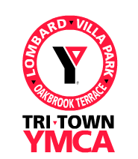
Hey Moms and Dads!

Looking for an easy and fun way to spend quality time with your kids? Join the Tri-Town YMCA Parent / Child Programs:

- Papoose: 3 - 5/6 year old parent/child
- Maidens: K-5th Grade mom/daughter
- Guides: K-5th Grade dad/son
- Braves: K-5th Grade mom/son
- Princesses: K-5th Grade dad/daughter
- Trailblazers: 6th – 12th Grade parent/child

Each group has a monthly meeting and an age appropriate monthly outing.


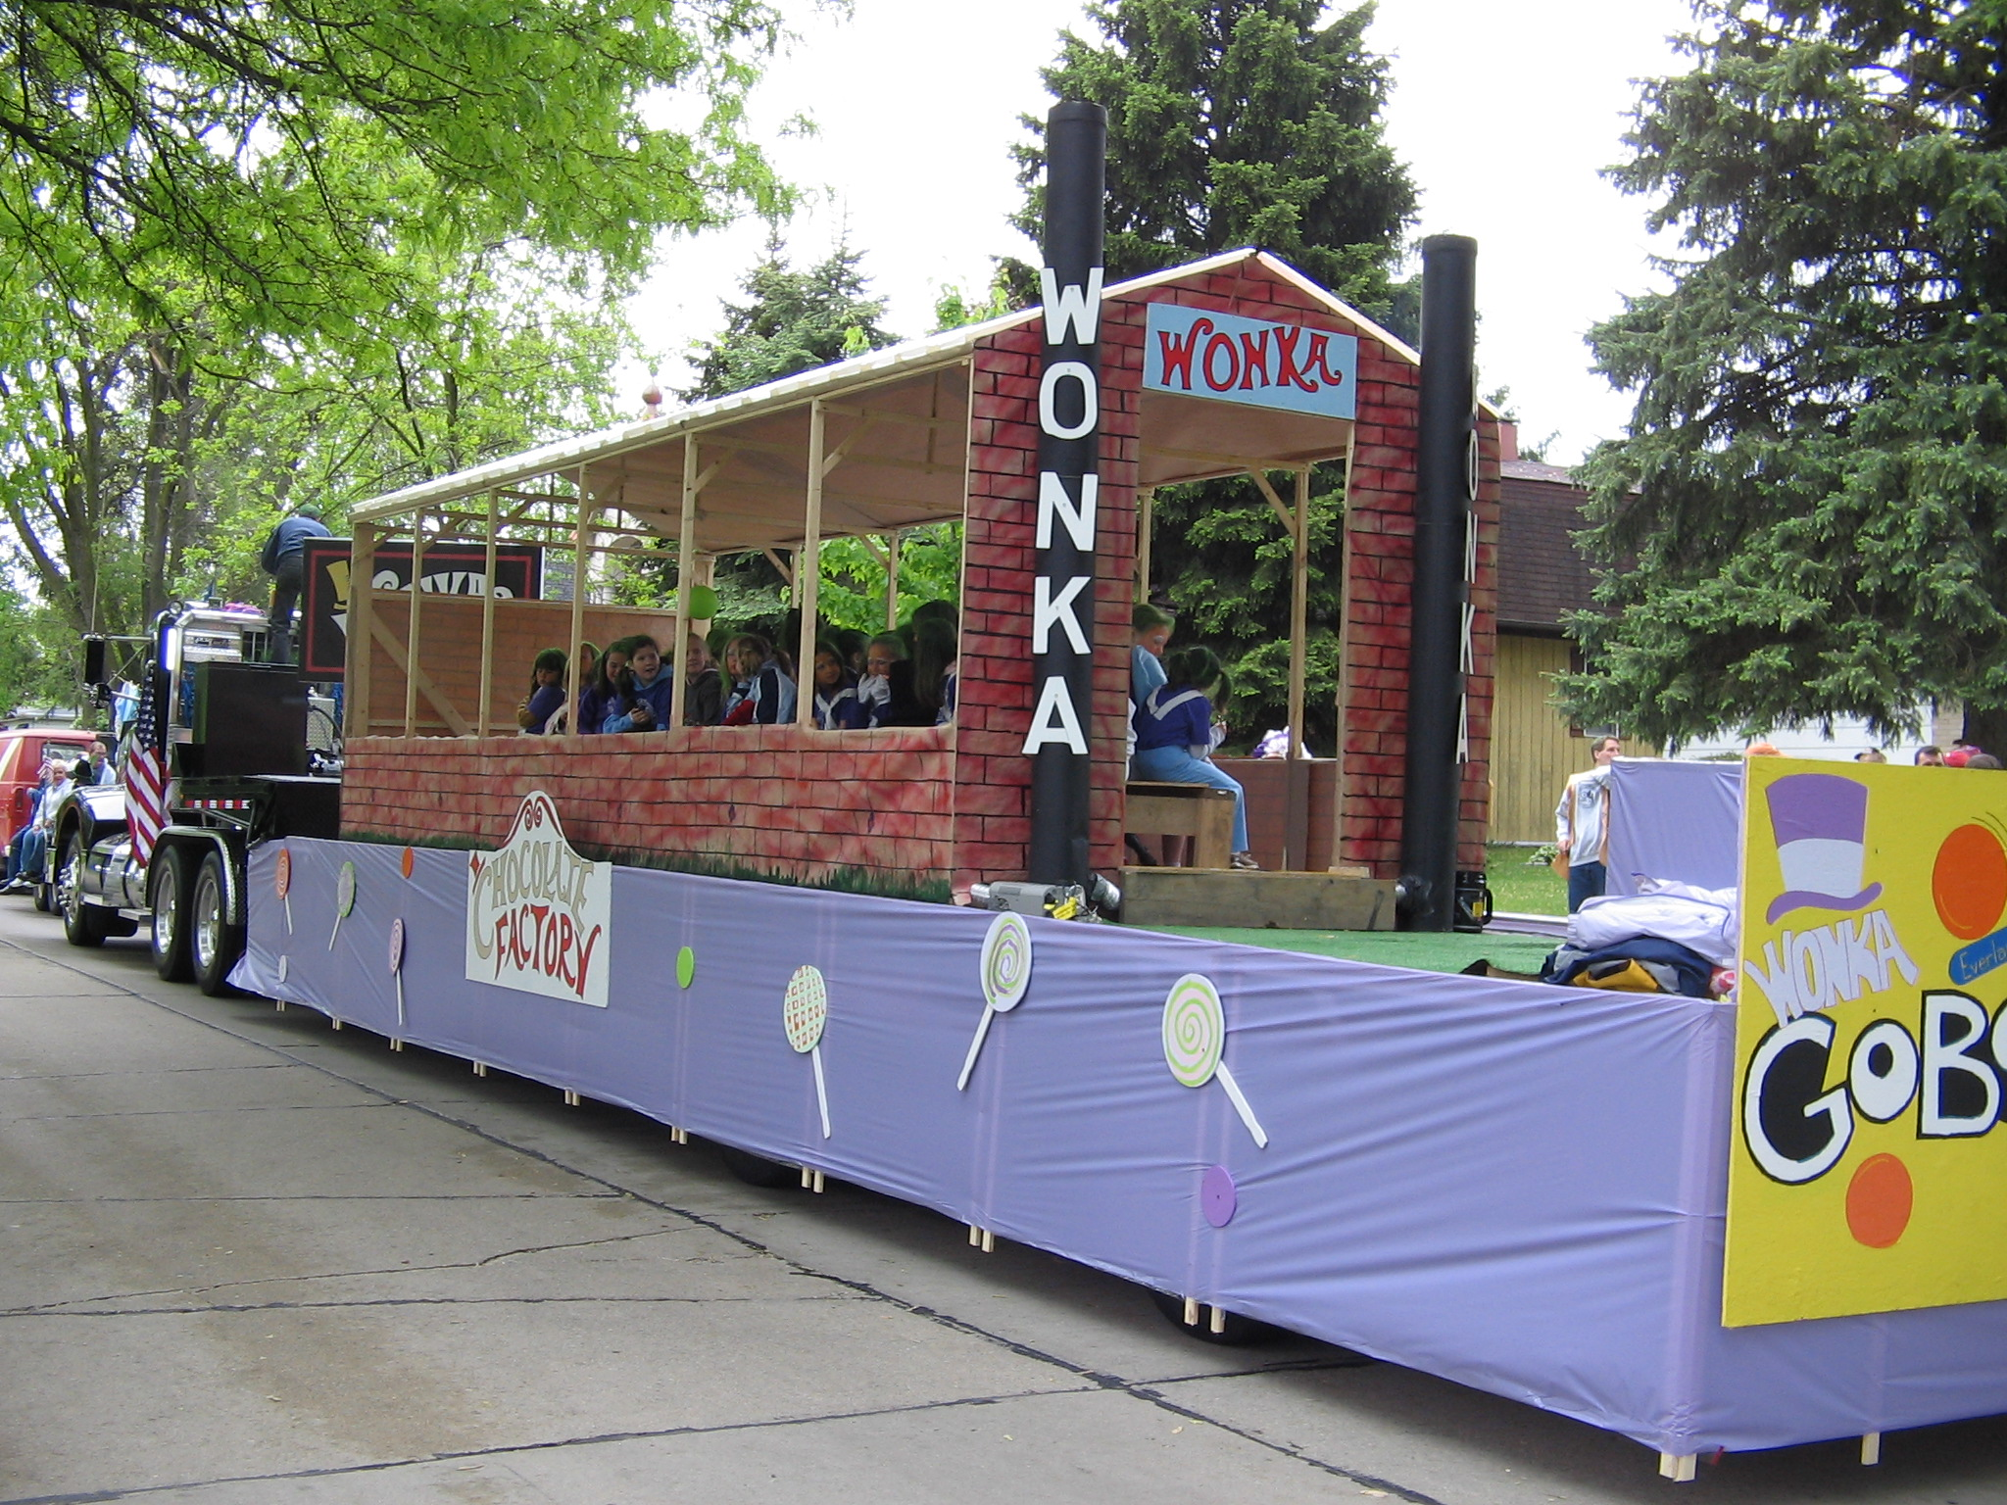

The next registration is September 11th at Madison school from 6:30 to 8:30 PM. Want to get involved sooner? Have questions?

General: Call Chuck at the Tri-Town YMCA, 629-9622.

Web Site: http://www.tworiversfederation.com

